Principles of DevOps- LAB 4

Anisha S

22BCS008

**Experiment Steps:**

**Step 1: Creating a Repository**

* Sign in to your Bitbucket account.
* Click the "Create" button to create a new repository.

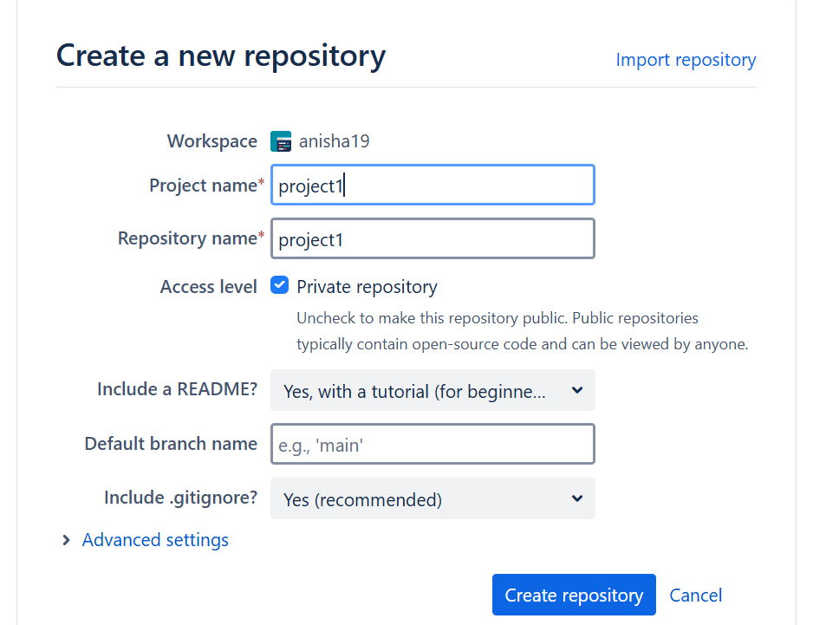

* Choose a repository name, visibility (public or private), and other settings.
* Click "Create repository."

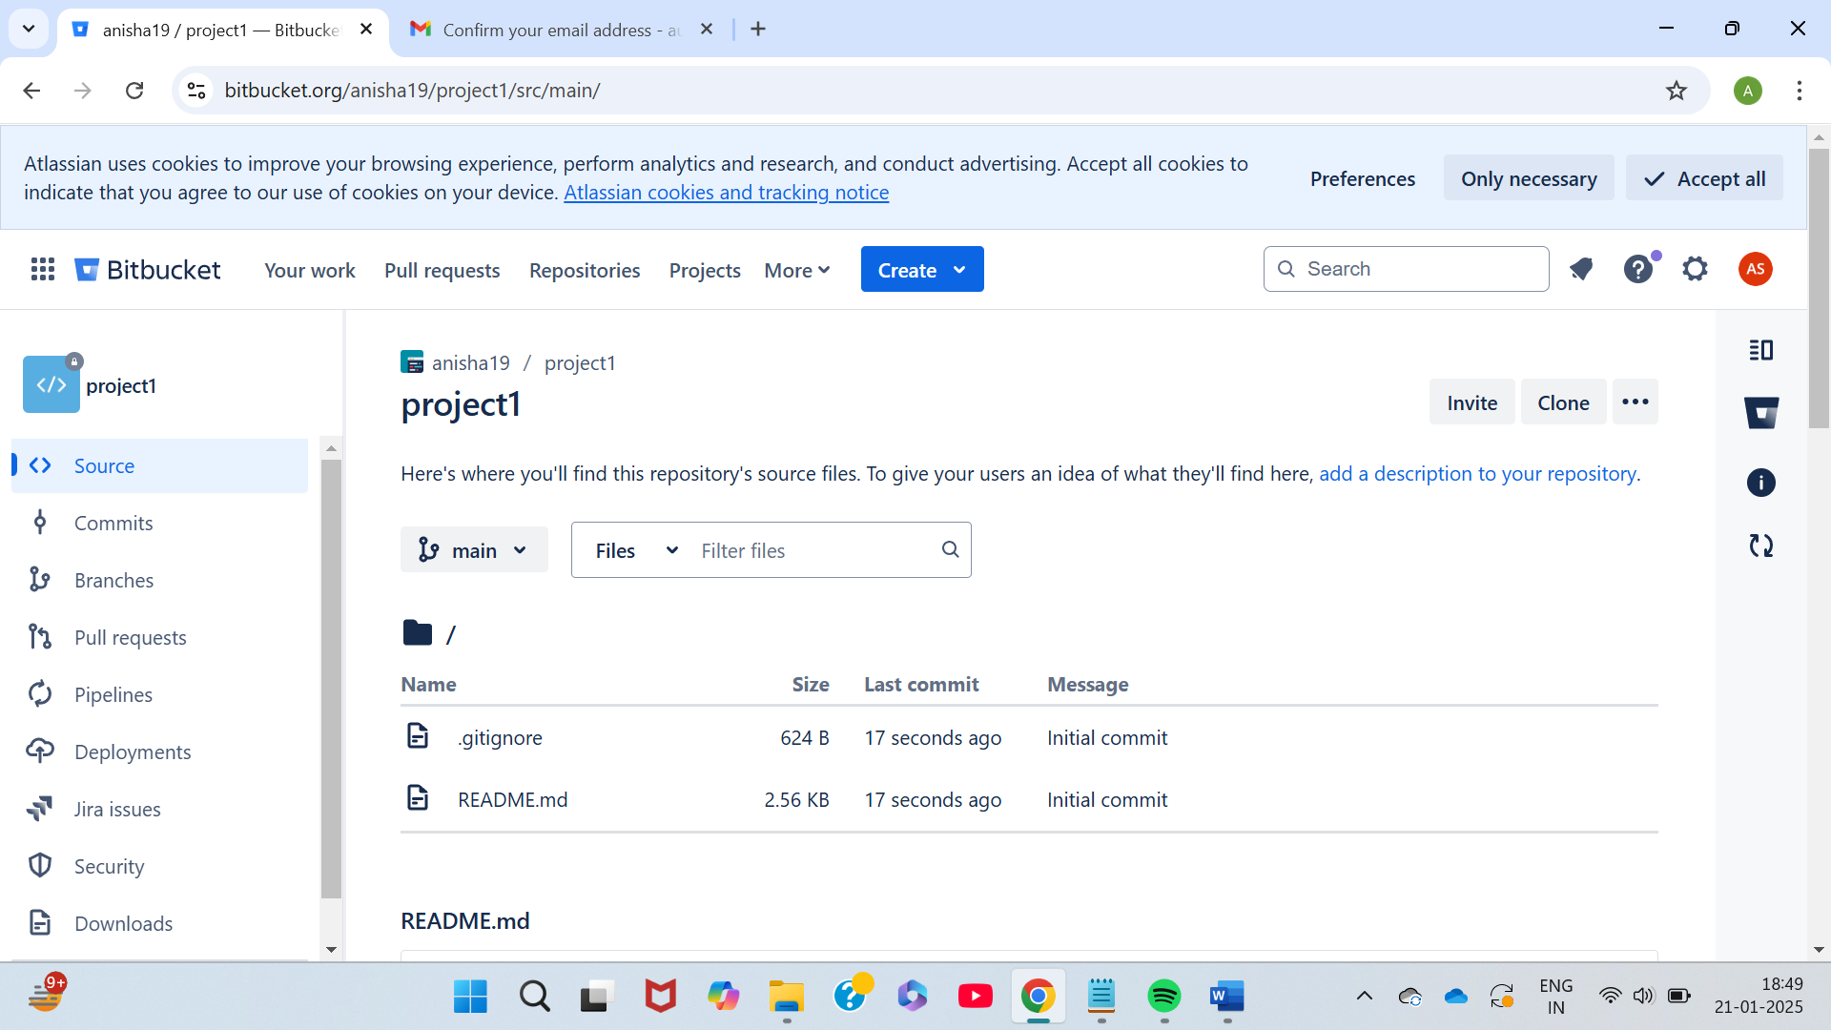

**Step 2: Cloning a Repository**

* Open your terminal or command prompt.
* Navigate to the directory where you want to clone the repository.
* Copy the repository URL from Bitbucket.
* Run the following command:

***git clone <repository_url>***

* Replace <repository_url> with the URL you copied from Bitbucket.

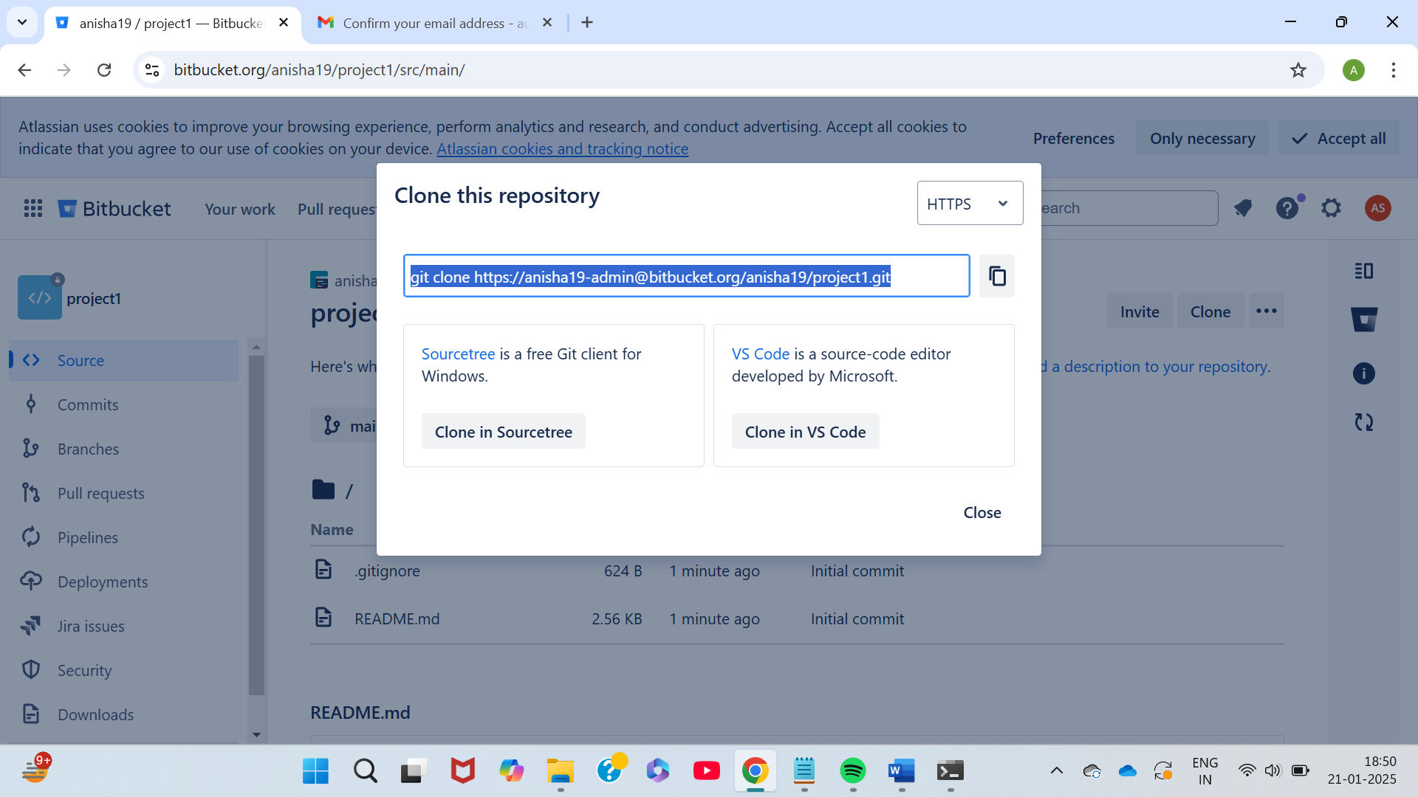

* This will clone the repository to your local machine.

**Step 3: Making Changes and Creating a Branch**

* Navigate into the cloned repository:

***cd <repository_name>***

* Create a new text file named "example.txt" using a text editor.

* Add some content to the "example.txt" file.
* Save the file and return to the command line.
* Check the status of the repository:

***git status***

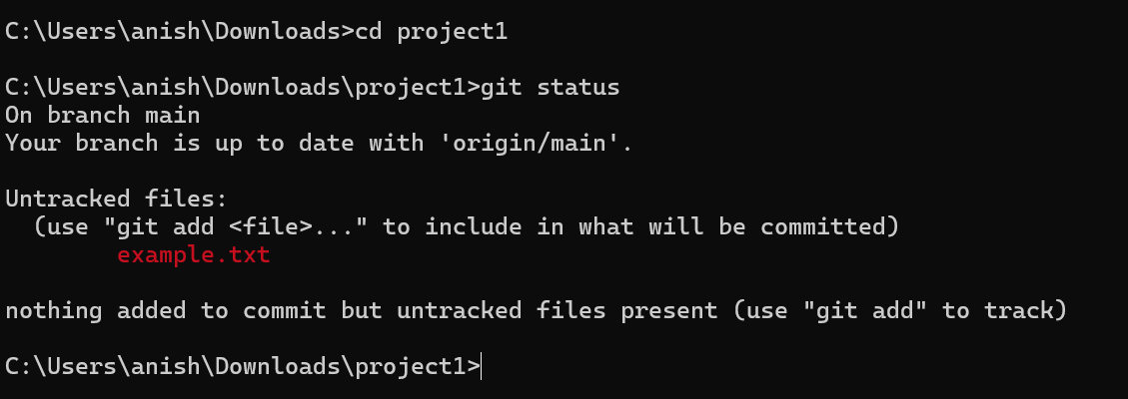

* Stage the changes for commit:

***git add example.txt***

* Commit the changes with a descriptive message:

***git commit -m "Add content to example.txt"***

* Create a new branch named "feature":

***git branch feature***

* Switch to the "feature" branch:

***git checkout feature***

**Step 4: Pushing Changes to Bitbucket**

* Add Repository URL in a variable

***git remote add origin  <repository_url>***

* Replace <repository_url> with the URL you copied from Bitbucket.



* Push the "feature" branch to Bitbucket:

***git push origin feature***

* Check your Bitbucket repository to confirm that the new branch "feature" is available.

**Step 5: Collaborating through Pull Requests**

1. Create a pull request on Bitbucket:

* Go to the repository on Bitbucket.
* Click on "Create pull request."

* Choose the source branch ("feature") and the target branch ("main" or "master").
* Review the changes and click "Create pull request."

1. Review and merge the pull request:
   * Add a title and description for the pull request.
   * Assign reviewers if needed.
   * Once the pull request is approved, merge it into the target branch.

**Step 6: Syncing Changes**

* After the pull request is merged, update your local repository:

***git checkout main***

***git pull origin main***



